1. **Part A: The Basic HTTP GET & Response Interaction**

1.1GET MESSAGE

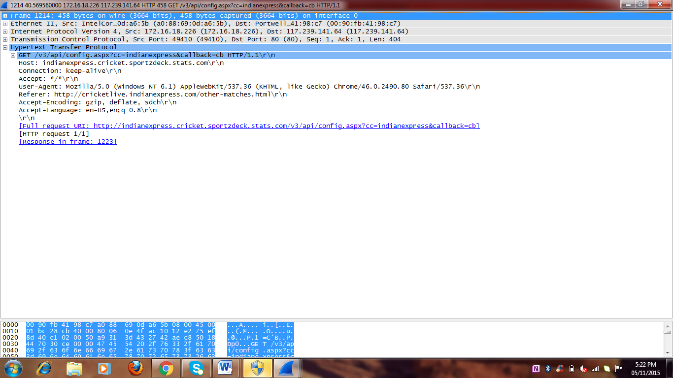

1.2RESPONSE MESSAGE

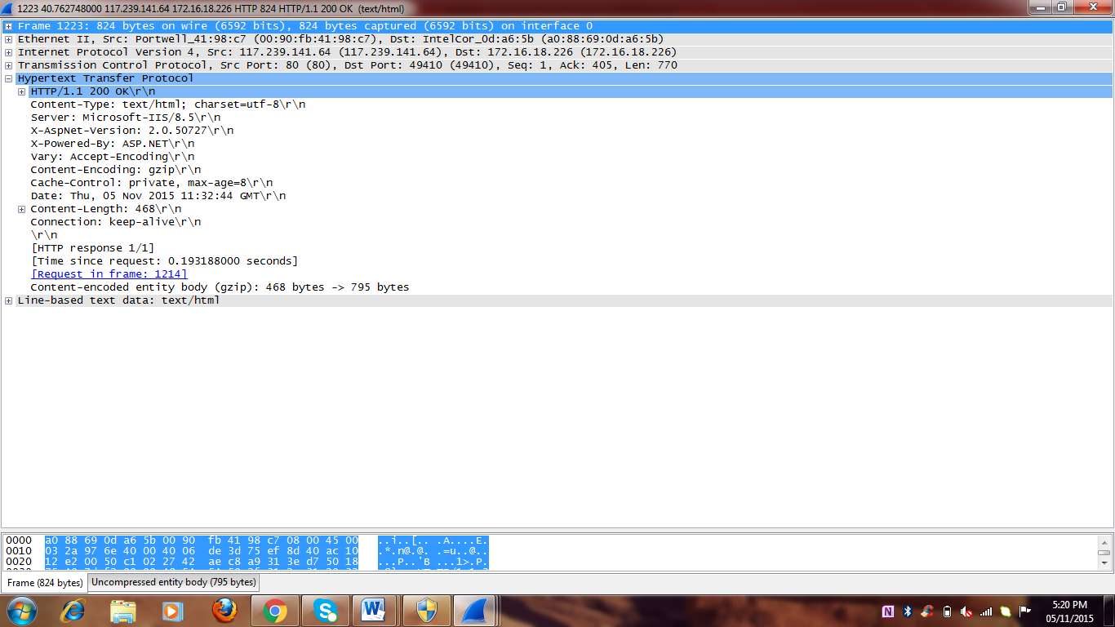

**By looking at the information in the HTTP GET and response messages, answer the following questions:**

**1.3VERSION OF HTTP AND VERSION OF HTTP SERVER**



**By looking at the information in the HTTP GET and response messages, answer the following questions:**

1. Is your browser running HTTP version 1.0 or 1.1? What version of HTTP is the server running?

**ANS: HTTP/1.1 The Version of HTTP server running is Microsoft-IIS/8.5\r\n**

**1.4 LANGUAGE INDICATED TO SERVER**

b)What languages (if any) does your browser indicate to the server that it can accept?

**ANS:Acceptlanguage:en-US,en;q=8.5\r\n**



**1.5 IP ADDRESS OF COMPUTER AND SERVER**

1. What is the IP address of your computer? What about the server?

Ans) IP address of source : 172.31.99.6

IP address of server is: 54.192.156.198

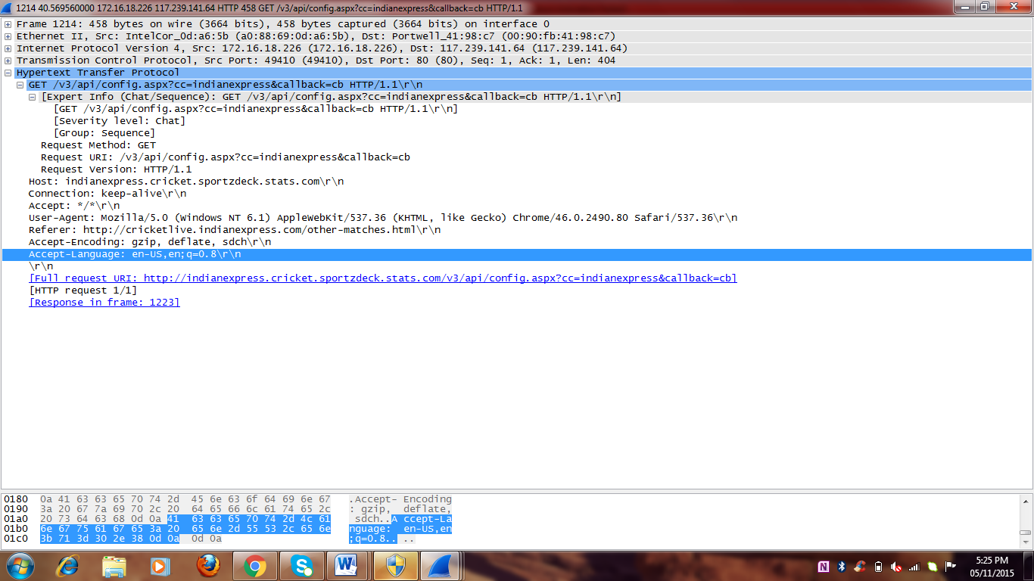

**1.6 STATUS CODE**

d)What is the status code returned from the server to your browser?

Ans) 200

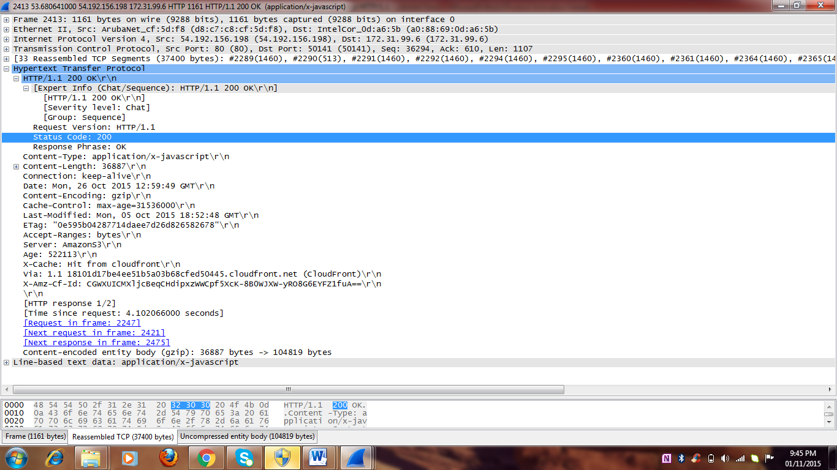

**1.7 MODIFICATION DATE OF SERVER**

e)When was the HTML file that you are retrieving last modified at the server?

Ans) Mon,05oct 2015 18:52:48

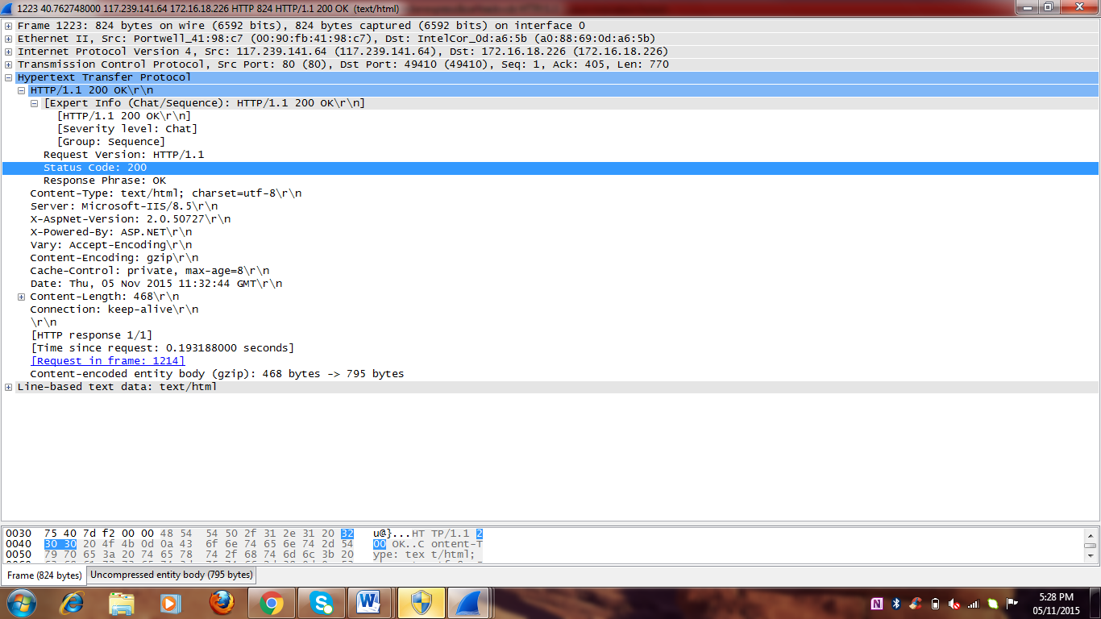

**1.8CONTENT OF BYTES**

f)How many bytes of content are being returned to your browser?

Ans)468

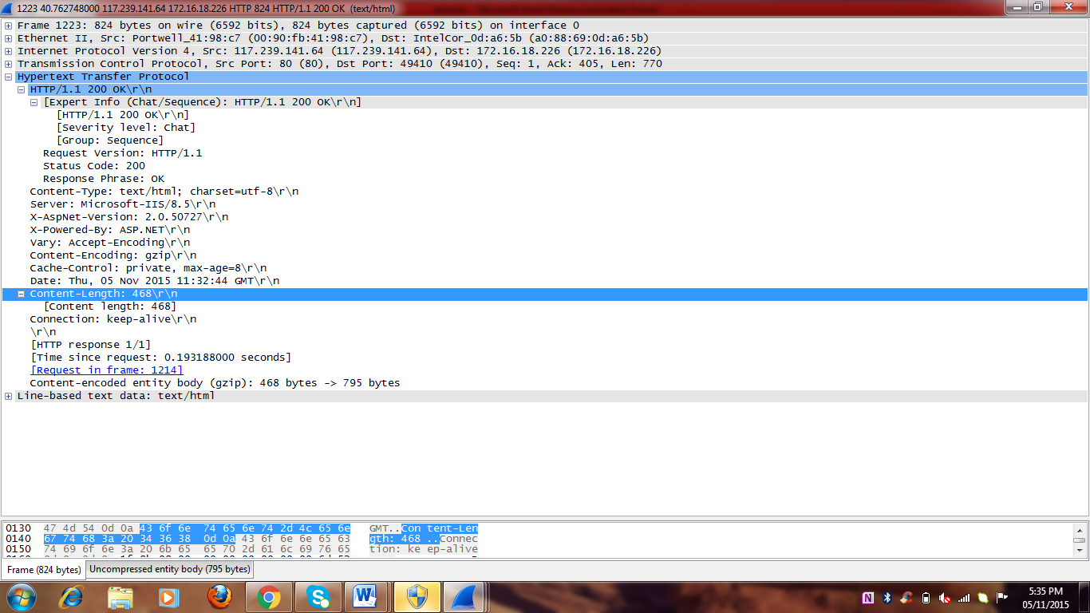

.

**1.9)RAW DATA IN PACKET WINDOW**  
g) By inspecting the raw data in the packet content window, do you see any headers within the data that are not displayed in the packet-listing window? If so, name one

**ANS: NO, the raw data in the packet-content window appears to match up exactly with what is shown in the packet-listing window.**

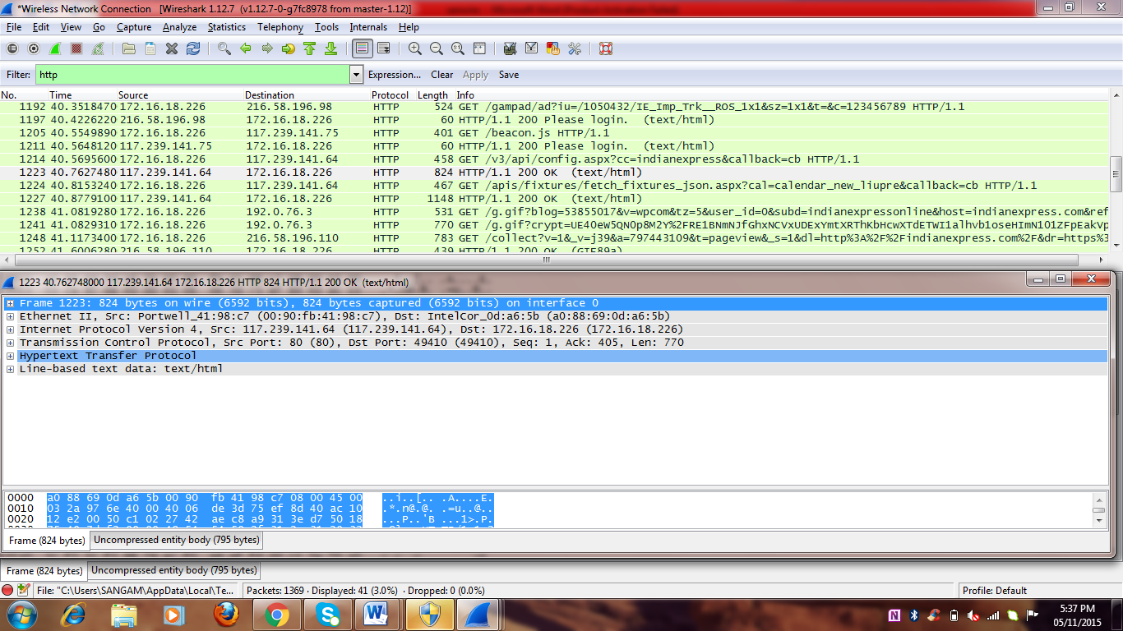

**Part B: Retrieving Long Documents**

**2.1 HTTP GET MESSAGE FOR LONG DOCUMENTS**

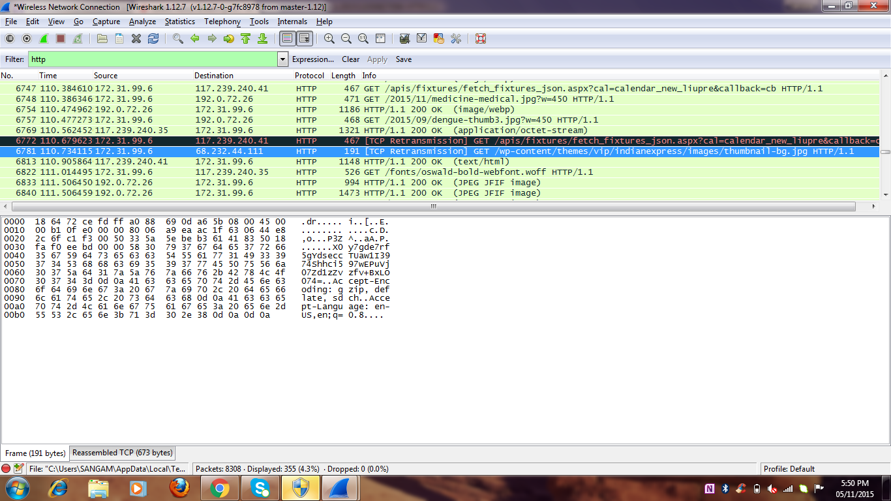

**Answer the following questions:-**

1. **Which packet number in the trace contains the GET message for the indianexpress.com LOGIN ?**

**Ans)6781**

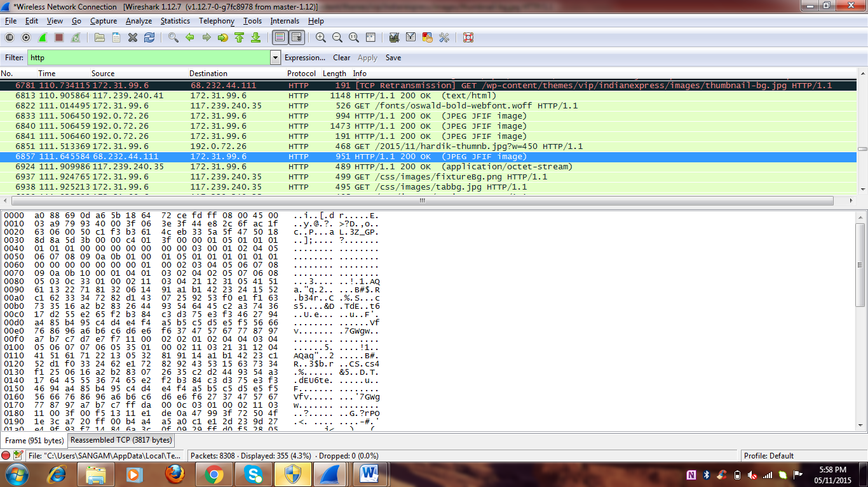

**2.2 PACKET NUMBER OF HTTP GET MESSAGE**

B)Which packet number in the trace contains the status code and phrase associated with the response to the HTTP GET request?

Ans)6857

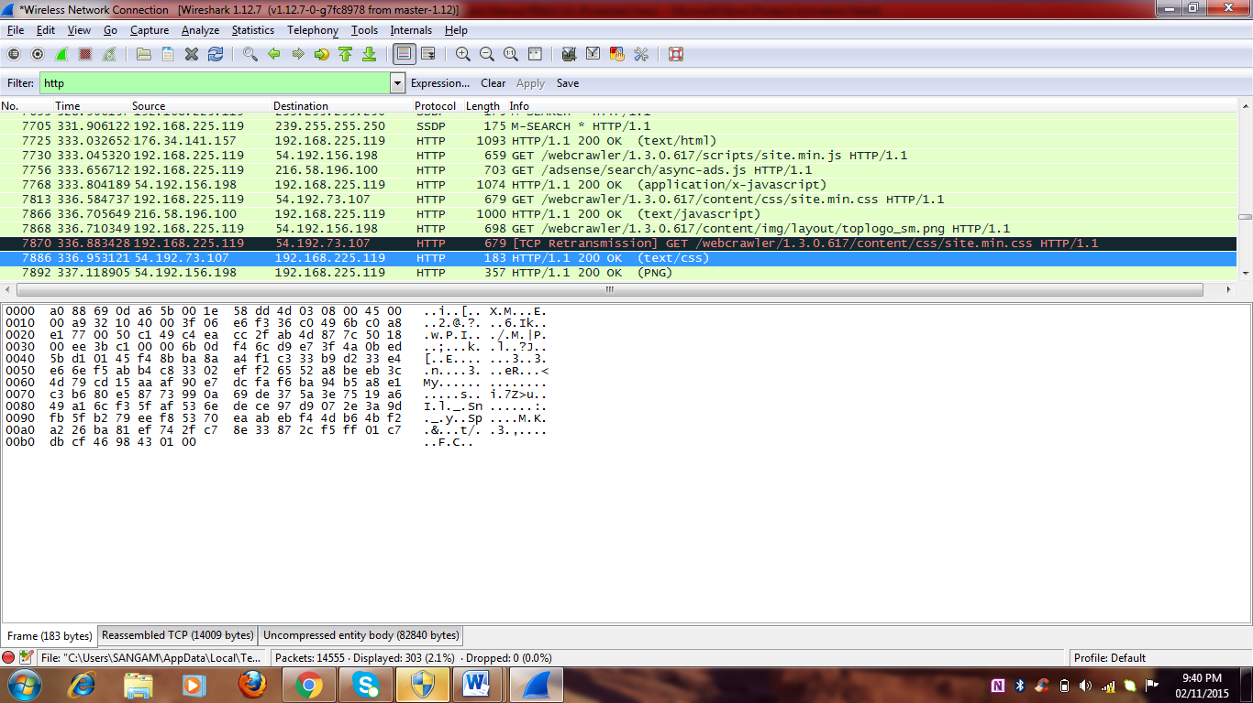

**2.2)STATUS CODE AND PHRASE**

c)What is the status code and phrase in the response?

Ans)The answer is

STATUS CODE: 200

RESPONSE PHRASE: OK

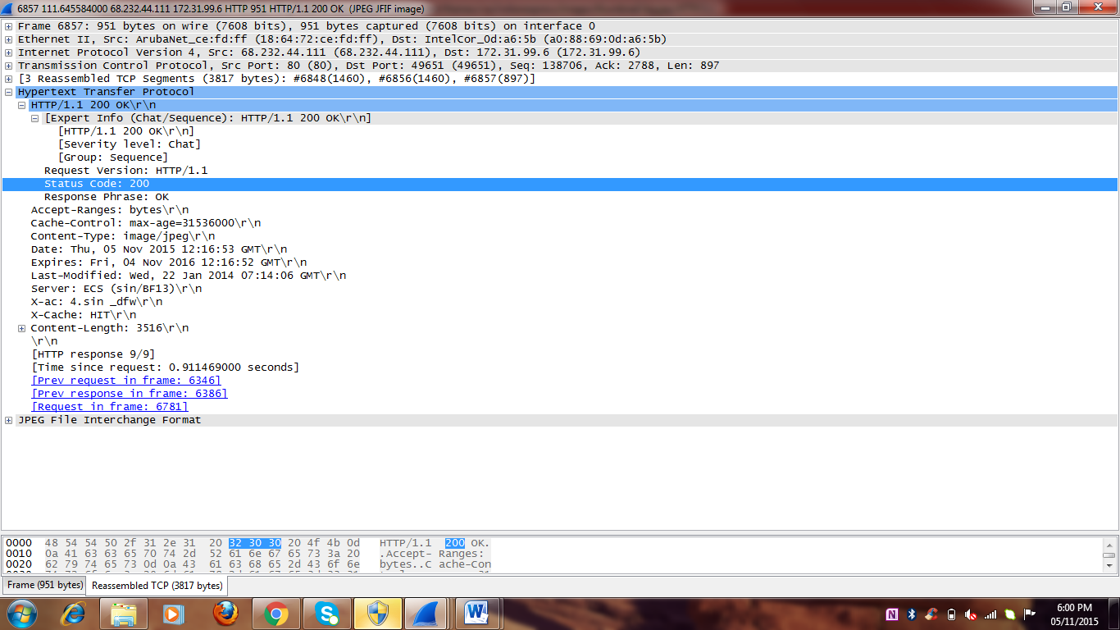

**2.3)DATA CONTAINING TCP**

d)How many data-containing TCP segments were needed to carry the single HTTP response.

Ans)2reassembled TCP Segments

